The Bilyaks

First Quarter Report 2017

January/February

What do you do when there’s a war in your country? What should we, as a church, do in that situation? Those are the very questions I have been asking myself and the leaders of our church.
As you already know, there is a war going on in Eastern Ukraine. In our country, due to political considerations, it is called an Anti-Terrorist Operation. But that doesn’t change the bottom line. There, people constantly perish. There are waves of refugees. As a citizen, it angers me that Russia is supporting this aggression against my country. If not for their armaments and their troops, this conflict would have been over long ago. Here is a recent quotation from the Ministry of Internal Affairs of Ukraine: “Since the beginning of the armed aggression of Russia against Ukraine that began on February 20, 2014, more than 9,800 people have perished (of that number, 2,608 were Ukrainian servicemen), and another 23,000 have been wounded: nearly 1 million 800 thousand persons have been displaced. The aggressor government has captured 7.2% of Ukraine’s territory. There is a 409.7-km stretch of Ukrainian-Russian border uncontrolled by the Ukrainian authorities through which Russia constantly sends new mercenaries, weapons, and ammunition into Ukraine.” (https://ru.tsn.ua/politika/ot-nachala-voyny-kremlya-protiv-ukrainy-pogiblo-pochti-10-tysyach-chelovek-mid-808560.html)
Looking at this conflict from the perspective of human reasoning, there is no hope… We understand that only by God's intervention can there be a solution. So of course, in every prayer, we pray about this to the Lord and ask all of our friends to pray for peace in Ukraine.
In the middle of such reflections, we considered how our small, young church could serve such people in our country. Moreover, we understand that God is also on the side of the oppressed: “He doth execute the judgment of the fatherless and widow, and loveth the stranger, in giving him food and raiment. Love ye therefore the stranger: for ye were strangers in the land of Egypt” (Deut. 10:18-19).
We began by considering what we had to offer. We had received a container of humanitarian aid from BIEM. Some of that aid we had distributed among people in our city, but some of it we still had. We took stock and realized that we could send one small load of aid. What do we have besides a desire to help the needy? We have friends! We have BIEM! I began to give information to churches with which we have friendly ties. And I wrote to the mission, and God began to create opportunities. The first to respond was BIEM. They named a specific sum they could offer for this outreach, and that was a clear sign from God. Next two Baptist churches got on board the project.
From conversations with brethren, we understood that the main need for people in that region is for food. It would be senseless to haul groceries all the way from Western Ukraine to the east. We could buy food there in the east.
We also needed to decide where specifically to go – to which city, and through whom could we work? Through a church, or through volunteers? Right now, the attention of the media and people is on the city Avdeevka, which is close to Donetsk. Two weeks before our trip, it was seriously shelled by heavy artillery, and they continue to shoot at it. In the city, there were and still are many victims. But after conversations with people who work there, we understood that, due to the attention of the mass media, much humanitarian aid (clothing) is being taken there. There is a great need for food and for money for gasoline to serve these people.
The president of our Baptist brotherhood recommended to us one church from our brotherhood, and that church is actively working in this regard. After prayer and telephone conversations, we accepted the decision to transport humanitarian aid to Dobropolye and to deliver it to these brethren recommended by Sergei Mikhailovich Shaptala (president of the brotherhood). We decided to give a portion of the money given for this purpose to these brethren. In our planning, we desired to render aid to several churches. Even though it was dangerous, we wanted to visit Avdeevka to minister to people on the front line. We decided not to delay the trip. Within a week of the first consultation, we were on the road.
The collection team. Roman took 9 cans of liquid laundry detergent. It turned out very handy – a church in Dobropole has a laundry for displaced persons.

Our Christian sisters at church helped to prepare clothing, sets of sheets and blankets. The men from the rehabilitation center took on themselves responsibility for loading the vehicle. Along with me went Volodya, Andrei, and Roman. The cargo transport was in front, and we rode behind it for 1,100 km. We set out very early, and by evening we were in Dobropolye.

Ministry in Dobropolye
First, we unloaded our van into the church warehouse and released our cargo vehicle. Then we had a chance to get acquainted with the church and their ministry.
The church in Dobropolye isn’t large, but it’s quite dynamic in ministry. Their church building is very modest from the viewpoint of comfort and repairs, but their hearts are large with a desire to serve people who are in great need. Unfortunately, their opportunity to serve people hinges on the sacrifices of others. Igor Gutnik, pastor of the church Light of the Gospel, wrote the following in his letter of thanks:
“We started with charitable, hot meals for which we did not have anything. One dinner cost us then 500 griven [Ukrainian currency]. Every Wednesday 50 to 100 people came. We never knew how many people the Lord would send. Every Wednesday we received them, fed them, then sang Christian psalms and read the Gospel with them. When the refugees increased, we started visiting them in the nearer cities of Donetsk region on the Ukrainian side. We visited the cities of Novodonetskoe, Belozerskoye, Belitskoye, Rodinske, and Selidovo. Including Dobropolye, we served food packages and clothing to 1,300 people every month, once a month per person. We are very tired; we had no days off except Sundays. During the week we were always going somewhere.”
The actual city of Dobropolye isn’t huge. The population is about 30,000 residents. The main business is coal mining. In this modest-sized town, about 15,000 refugees have taken shelter. People have settled everywhere. In the vacant places of businesses, dormitories, private houses and apartments. Many settlers tried to find some sort of comfort in other regions of Ukraine or Russia, but eventually returned to their native regions. It is said that even the smell of coal smoke is more pleasant for them than clean air in other regions. Even if it isn’t home, it’s close to home.
Wednesday, February 15. It turned out that the weekly receiving of displaced persons happened to fall on the holiday of Sreteniya (the young Christ’s meeting Simeon and Anna). The church auditorium was filled to capacity with 120 people. Some had arrived almost an hour early, mostly out of a desire to talk with others. Several people arrived for the second half, obviously for the aid from the church. The service was not long, but it was nourishing. We sang several hymns. Brothers Volodya and Andrei shared from the Word and their testimonies.
After the worship service, people lined up as if on cue. Sisters from the church registered those who had come for the first time. The others wait, and also show their I.D.s to receive 4-5 kilograms of food, which the brethren purchased in advance using funds we had provided. In each packet there were Christian pamphlets, booklets. Anyone who did not own a New Testament received one. The people are varied. Some are very thankful and open to fellowship; others express no emotions and simply leave.

Meeting with refugees in Rodinske
After a quick lunch, we climb into cars and torture ourselves on the streets of Donetsk on our way to a neighboring city 35 km away. There, volunteers had gathered 50 people in a corridor near their office. No one could provide a more comfortable place. This gloomy corridor without windows was lit by two dim bulbs. When someone opens the door to the corridor, there is a flash of bright light reflecting from snow lying on the streets. In general, the picture is grim, as people today say, “Surrealism of the 1980s.”
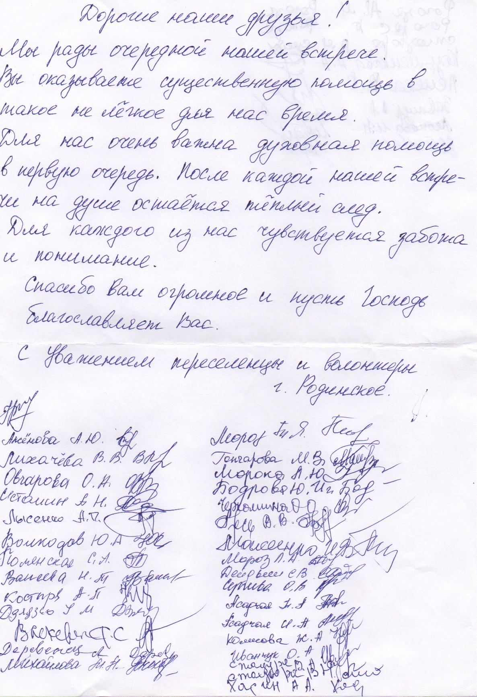
We slip into a corner of the corridor with a group of brothers and sisters, and immediately a service begins. Everyone stands. When we sing a song about home, many quietly wipe tears from her cheeks. It’s my turn to preach. I often preach. But I had not yet been listened to so attentively... I speak about the most important meeting that everyone needs – a meeting with the Savior. We sing a few songs and pray in the end. We invite people to come out to the car and receive some food assistance, and of course something for the soul. Then they gave me a letter of thanks signed by those who were at that meeting. After several expressions of gratitude, it has special words: “For us, the thing we need most of all is spiritual help. After each such gathering, a warm feeling remains in the soul. Each of us felt your care and understanding.”

Marina. A wife from Avdeevka.
Merely in glancing at her, you sense that this is a person who has gone through pain. In appearance she is not more than 35. At the time of our little worship service in the hallway of volunteers, she stood leaning on a walker. She is missing one leg. After the service she told me her story. When the war first broke out, during a time of military activity, a bombardment began. She realized she had no time to reach the basement (as a bomb shelter). She hugged her two small children to herself. When she woke up, she was severely wounded. They amputated her leg completely. She looks on her situation from the position of one who has suffered. She blames everyone who has taken weapons into their arms.

During her time of wandering from hospital to hospital around Ukraine, she has met many malevolent and even evil people. We prayed with her, that the Lord would give her peace in her heart. After our meeting in Rodinske, we had yet another meeting with men waiting for us. It was planned as an evangelistic meeting. Not a lot of unbelievers came, but there were several.
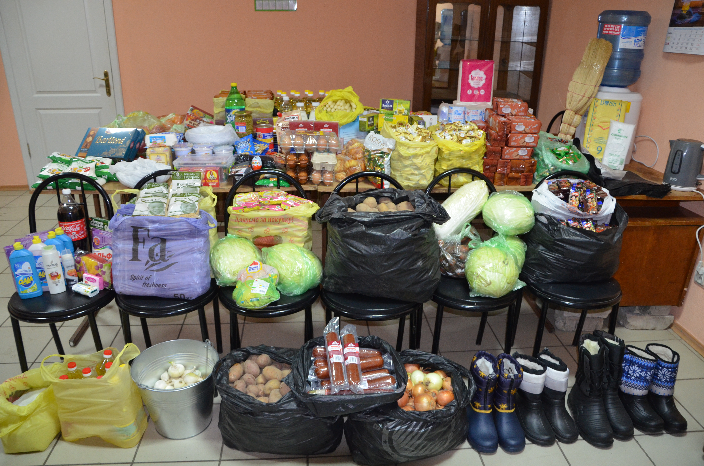
In the evening our dear friend and brother from Donetsk joined us. He is a pastor. His church ended up on the other side, under occupation. He continues to minister to these people. Every Saturday he loads up his old automobile with groceries on the Ukrainian side and drives it across to the other side. People come to the service. After a two-hour service, he leads a two-hour fellowship in the format of Sunday school for adults. He calls this ministry “Help to Survive!” In talking to him I learn many things that can’t be written. Since our last meeting, which was about three years ago, he has aged. Previously I knew him as a man of many smiles who loved to joke. Now he and his wife are heroes to me, people who risk their lives crossing the front twice a week in order to help believers on that side of the war. We gave him funds to buy food for people. He accepted some children’s blankets, towels, and sheets. We prayed, and he departed to his reality.
A couple of days later, I received a letter of thanks from him:
“I sincerely thank you for the support for the ministry “Help to Survive.” Part of the funds received from you went toward groceries, shoes, and other things for people…. Here, history repeats itself and occupied Ukraine has gone back 100 years: displacement, famine, and depression. Many people use an expression: ‘We will build your new world! He who was nobody will become everybody!’ Drug addicts and drunkards are now big people, and we are supposed to listen to them because they have weapons in their hands…. We live and work in a region where evil has been condensed, but here there is also a concentration of good – the Church of Jesus Christ.”
This is $300 worth of food bought on the Ukrainian side and carried across to the war zone.

Trip to the line of conflict
According to our plan, on the next day we were supposed to visit Avdeevka, a city that has been shot at by artillery for nearly a month. In the morning we were told that it had not been quiet during the night. A feeling of anxiety appears immediately at the 1st block-post checkpoint. Armed people examine our identifications and our cargo. When they learn that we are from Western Ukraine and that we are going to deliver aid to Avdeevka, they let us proceed without problems. There are five checkpoints along the 60 km road. Cars become less frequent. Closer to Avdeevka, there are practically no other civilian cars, only military vehicles. On the approaches to the city we understand that we are drawing close to the zone of military activities. Road signs and fences and houses have been riddled with shrapnel. On many homes, instead of glass in the windows there is plastic sheeting. There are houses where blown-out windows don’t even have plastic covering them.
A final checkpoint, and then we enter the city. The first thing we did was to visit the church. People waited for us at the church. They share the latest developments. In the morning brothers from the church rescued a grandfather and grandmother from a house where a shell had hit. The house burned. They brought them to the church and fed them and gave them tea while they considered were to live now. They also offered us buttered bread and tea. Before the war this church had youth; there were many brothers, preachers.
Now there is a catastrophic shortage of brethren. Most have departed to quiet regions. While we were in the church, we heard explosions, but none of the locals made a fuss, so why should we worry? We gave them boxes of aid and finances for the church funds. We don’t have a lot of time to spend in this city. It’s time to head home. For the next day, there is an evangelistic meeting planned for our church back home.
The local brothers suggested we go and take a look at the buildings that had been shelled during the night. If it wasn’t dangerous, why not go and look? They tell us that there is also a possibility of gunfire in the afternoon, but that all movement occurs at night, when the OSCE patrols leave the city. When we reached the street that had been hit, we understand what war is. Broken wires. Destroyed houses, sheds, fences... In the windows there is plywood instead of glass.
While we gaze on the destruction, we talk with people. Once again, shooting breaks out. But the locals don’t react. Everyone has the same question: When will all this end? And it seems that, to the locals, it makes no difference who wins, just so long as the shooting stops and peace returns.

This apartment building was shelled a week and a half before our arrival.
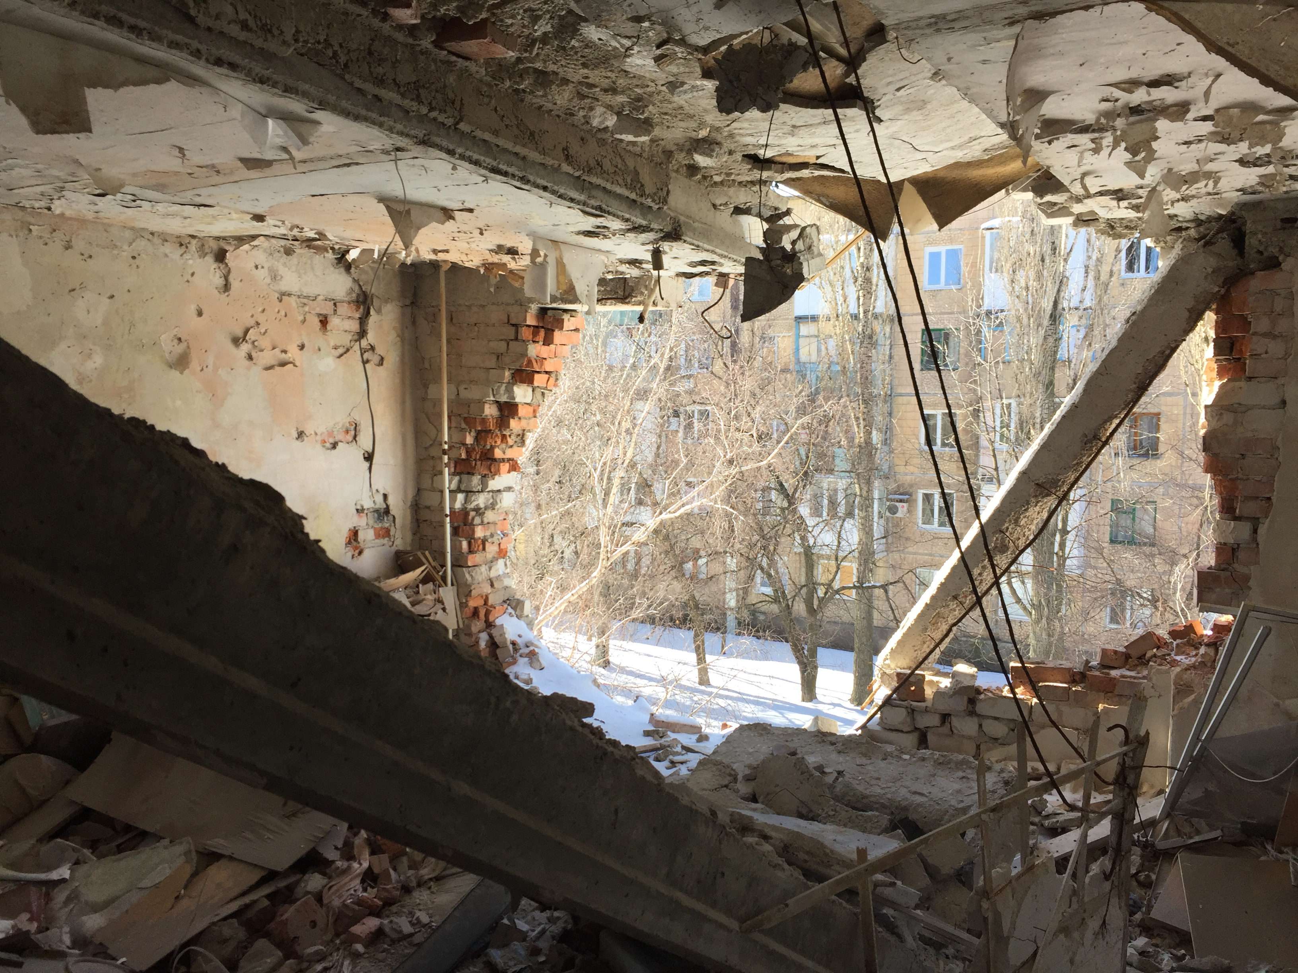
You can’t see all this and remain apathetic. We leave with conflicting emotions. We understand that some 5 checkpoints separate us from normal life. We departed to peaceful territories, but they remained behind to live there, or more accurately, to survive. The farther we get from the zone of conflict, the more peaceful it becomes. There may be potholes where someone from the road service hasn’t done their job, but at least there is peace.
We returned home, where we read in the news that several hours after our departure Avdeevka was heavily shelled. Apartment buildings were hit, and people died. More homes destroyed, lives snuffed out. Reflecting on what we saw, a prayer is born in my mind: “Lord, we thank You for peace in our part of Ukraine! We are no better than those people in the conflict zone. We thank you for being merciful to us!”
Please pray for Ukraine! Pray especially for the churches, which are on both sides of the conflict line. Pray that each of us will understand what is his role in serving suffering people in this senseless war.

March

Service dedicating the new meeting place for worship!

Greetings to you, dear friends and coworkers, partners with the BIEM mission!
For me, it’s always a great comfort and encouragement to know that we have a large ministry team. And such letters are always an important part of ministry, because I understand well that you should be in the know concerning our successes, and of course we want to know of our concerns.
And so… this happened! On January 29, 2017, we officially and fully moved into our auditorium for worship services. How terrific it is to say now, “Our auditorium”!
We understand that this building is a gift from the Lord! And we are just stewards of what the Lord has given us to use. There was a time when we moved from place to place. We experienced surprises when landlords gave us new conditions, when they changed rental fees, when they changed the interiors of the meeting place.... We prayed for a permanent place, and we asked you to pray, and you prayed with us! About two years ago, the brothers from the mission called and said, “There is hope that God is beginning to answer our prayers.” And it happened! Through His people, God gave the opportunity to buy part of a building in the center of the city. It was wonderful. We immediately transferred part of the ministry to our still unrepaired building, but for some time we continued to rent a hall for worship services. Then, when the men had completed a small room, the services were moved there. At the same time, repairs on the main floor continued. And in January the worship hall was ready.
In the Book of Nehemiah we read that, when part of their work project was completed, the people celebrated. We, too, celebrated! At the first worship service, the dedication, believers came from other churches with which we have friendly ties. Also Samuel Slobodian came. There were marvelous sermons, songs, and good wishes. But the main part was a prayer of dedication! What a pity that we can’t convey to you by letter the joyous atmosphere we had here.
Many people and guests expressed a desire to attend a regular worship service here. We decided to extend our holiday for a month and a half. After the dedication Sunday, at each service over the next several weeks guests visited us from other churches around Ukraine. Both near and faraway guests visited us for the next 6 Sundays. This was a wonderful time of getting acquainted with other Christians and thereby obtaining more prayer partners.
The blessing that we are experiencing after the opening is an increase in the number of people attending church. It's hard for me to explain this, but since we moved into our new premises, we have new people visiting almost every week. Some came for the first time to the dedication service and have been coming here for several months.
I like that from the moment we had our own location, people from the church and outside the church began to treat the us differently. It seems that they tacitly realized this is now more serious. We used to change the location of the church in the past, but now people understand – "This is serious" and relate to the church more seriously.
Friends, we praise God for you, and for your open hearts for the needs of Ukraine. We very well understand that without your donations we would not have our beautiful building. Thank you for supporting us, not only in purchasing it, but also in the reconstruction of the premises.
We also have several prayer needs. Yes, there are many of them, but there are several of the more urgent ones:

• We pray for a youth minister in the church. In our city there are more than 40,000 students. There are also young people in the church. But there is no youth leader. I still need to hold youth meetings.
• Pray for audio equipment for worship. We brought our old equipment to the new hall, which we had bought used and have since then used everywhere: in camps, and in our worship services when renting various premises. At the first service, the equipment still worked well, but then the sound grew worse and worse. Our speakers died. We had very large, old speakers in the basement and have started using them. Once we put them away because of their low quality, but now they are the best we have.
• Pray for the opportunity to complete the repair of the basement level.
• Pray for the preparation and holding of summer camps. This summer we are planning a youth and teenage extreme camp in Karat. Then, we will conduct the project "Choose Life" (a day camp for children near the church and a social project). Pray that God will bring new people to church through the camping ministry.
• Pray for the humanitarian aid coming to us by container from the mission, that it will clear Customs. It is still on the way: we need to do a lot of work with the documents.

With best wishes, your brother in Jesus Christ,
Vitaly Bilyak

